Feds rescue 69 child
prostitutes; bust 99
pimps and hundreds
of other adults in
nationwide sting

BY Philip Caulfield
DAILY NEWS STAFF WRITER
Tuesday, November 9th 2010, 10:26 AM

GettyFederal agents busted more than 880 adults in a
three-day sting that focused on breaking up child
prostitution rings across the U.S.

A three-day federal crackdown on child prostitution
across the country busted 99 pimps and led to the
rescue of 69 teenage prostitutes in 30 states and the
District of Columbia, the FBI announced.

The FBI said federal agents and local and state
police rounded up more than 880 adults on charges
related to the sexual exploitation of minors, human
trafficking and prostitution activities.
The children and pimps were rounded up during a
72-hour nationwide sweep of 40 cities known as
Operation Cross Country V, an annual crackdown
targeting child prostitution as part of the Innocence
Lost National Initiative, the FBI said.
More than 2,100 police and law enforcement
officials were involved in the operation.
The rescued children were between 12-and- 17-
years-old. Twenty-four children, nearly a third of
those rescued, were found in the greater Seattle
region, the largest group to be found in a single
city.
The Seattle area has led the nation in number of
juvenile prostitutes saved for the past three years,
an FBI spokesman told local radio station KPLU.
FBI executive assistant director Shawn Henry told
The Associated Press that child prostitutes are often
recruited by loose knit groups that specifically seek
out young drug users or scared runaways.
"There are groups of people out there preying on
naive kids who don't have a good sense of the way
of the world," Henry said. "Sometimes there's a threat
of force, threats of violence. A lot these kids operate
out of a sense of fear."
As part of the operation, Feds scoured truck stops,
casinos, seedy city streets, websites and chat
boards looking for prostitutes, pimps and Johns.
Seattle wasn't the only major city left red-faced after
the nationwide sting. Police and agents in the
Chicago area busted 39 adults and six pimps and
rescued at least three underage girls, the Chicago

Get Morning Home Delivery of the Daily News for up to 70% off.
Call (888) 393-3760
Advertisement
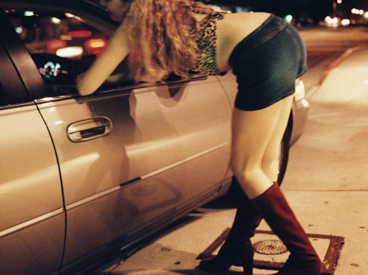

Sun-Times reported.
In the Bay Area, police and agents busted 72 pimps,
prostitutes and Johns and recovered three children,
the Contra Costa Times reported.
Authorities are working with the National Center for
Missing and Exploited Children to confirm their
identities, the FBI said.
Nearly 1,250 child prostitutes have been located
and removed from prostitution since 2003, when
the FBI and the Justice Department launched the
Innocence Lost National Initiative.
With Wire News Services
pcaulfield@nydailynews.com

